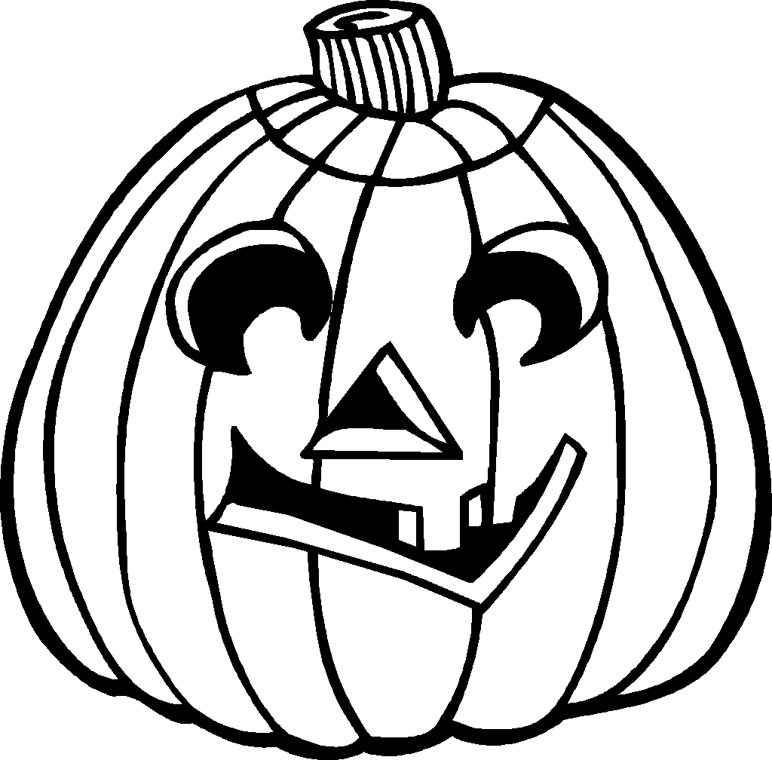
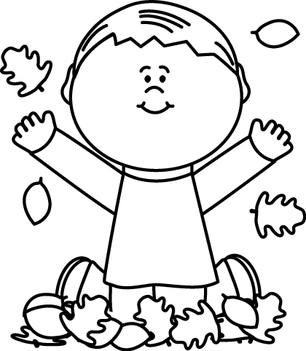
October 2017
Sunday | Monday | Tuesday | Wednesday | Thursday | Friday | Saturday
1 | 2 | 3 | 4 | 5 | 6 | 7
 | Computers/Art | Science/Music | PICTURE DAY  PE/Guidance | FALL BREAK | FALL BREAK
8 | 9 | 10 | 11 | 12 | 13 | 14
 | Computers/Art | Science/Music | FIELD TRIP TO EVAN’S ORCHARD  PE/Guidance | MILLS OUT – SUB  Computers/Art | FALL FESTIVAL @ 5:30PM  Science/Music
15 | 16 | 17 | 18 | 19 | 20 | 21
 | PE/Guidance | Computers/Art | Science/Music | PE/Guidance | AFTERNOON MOVIE @ 3:00PM  Computers/Art
22 | 23 | 24 | 25 | 26 | 27 | 28
 | Science/Music | PE/Guidance | REPORT CARDS  Computers/Art | Science/Music | PE/Guidance
29 | 30 | 31
 | Computers/Art | HALLOWEEN  Science/Music

